**SWITCHES**

Switches are the devices that can use to turn off or turn on the particular signal,it can also change the direction of the applied electrical signal.

Generally switches are of two types:

1.Mechanical Switches

2.Electrical Switches

**Mechanical Switches:** Mechanical switch is a switch in which two metal plates touch each other to make a physical contact for the current to flow and separate from each other to interrupt the flow of current.

* **SPST(Single Pole Single Through)**

This is a simple ON/OFF switch. It is also called as On Way Switch. When a user press the button of the switch, then the plates of the switch connect with each other and the current starts to flow. 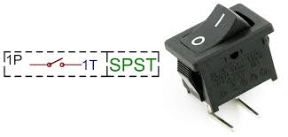

* SPDT(Single Pole Double Through)

This switch has three pins in which, one pin is used as common and called a Two-Way Switch We can send two different signals to same pin by using this switch. This switch is also called selector switch.

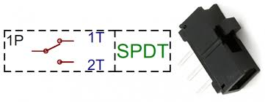

* **DPDT(Double Pole Double Through)**

This switch is equivalent to two SPDT switches packaged in one pack. This switch has two common pins and four signal pins. Total four different combination of singles can be applied to the input pins of this switch.

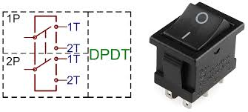

* 2P6T(2 Pole 6 Throw)

It is a type of the changeover switch with a common (COM) which may be connected to six lines with a second two pole switch, which controlling and the operation of the switch is same.

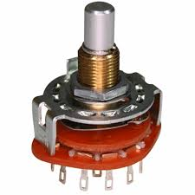

Some of the momentary switches are :

1.**Push Button:**In this type of switch when we push the button on the metal plates get connected and therefore circuit gets completed,as the circuit gets completed it starts conducting and therefore it is known as push switch

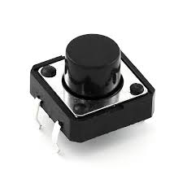

**2.Toggle Switch:It** is one of the most stable switch,switch knob can move in any direction.

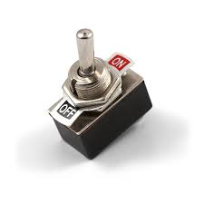

ELECTRICAL AND ELECTRONIC SWITCHES

**1.Transistor As Switch**

WORKING

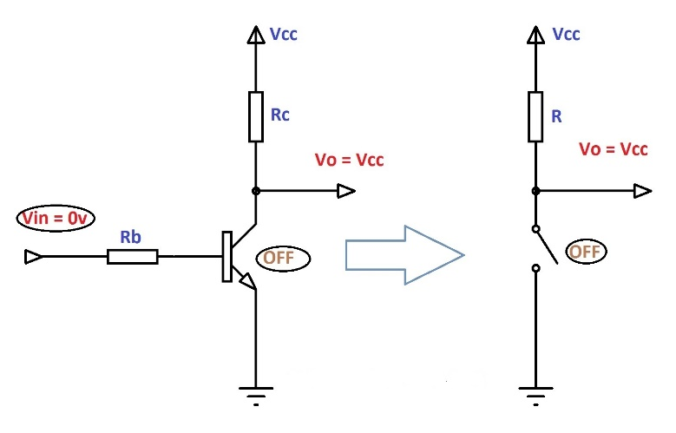

When the input voltage is zero then there is collector voltage present,asthere is no voltage difference between the input voltage and earth voltage so the switch is in open condition as no current flows through the transistor.

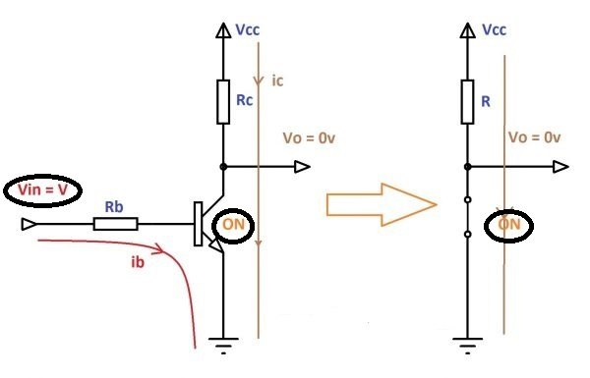

When sufficient input voltage is applied then the current starts flowing through the circuit as circuit gets completed as potential difference is created between the vin aand Vbe.

**2.Relay As Switch**

Relay consists of electromagnet which powers the switch,the switch is in on and off condition by the help of electromagnet.

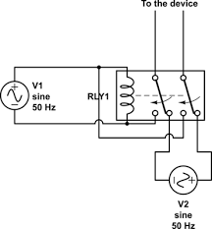

**MOSFET As Switch**

MOSFET basically stands for Metal Oxide Semiconductor Field Effect Transistor,IT consists of three terminals Source,Drain and Gate.

THIS FIGURE SHOWS WHEN MOSFET IS IN OPEN CONDITION:

|  |  |
| --- | --- |
| mosfet switch cut-off | * • The input and Gate are grounded ( 0V ) * • Gate-source voltage less than threshold voltage VGS < VTH * • MOSFET is “OFF” ( Cut-off region ) * • No Drain current flows ( ID = 0 Amps ) * • VOUT = VDS = VDD = ”1″ * • MOSFET operates as an “open switch” |

WHEN MOSFET IS IN CLOSED CONDITION:

|  |  |
| --- | --- |
| mostfet switch saturation | * • The input and Gate are connected to VDD * • Gate-source voltage is much greater than threshold voltage VGS > VTH * • MOSFET is “ON” ( saturation region ) * • Max Drain current flows ( ID = VDD / RL ) * • VDS = 0V (ideal saturation) * • Min channel resistance RDS(on) < 0.1Ω * • VOUT = VDS ≅ 0.2V due to RDS(on) * • MOSFET operates as a low resistance “closed switch” |

**CONNECTORS**

Connectors are devices which are used to complete the electrical circuits by connecting the various parts of the circuit.Some of the mentioned connectors are:

* **CRIMP ON CONNECTORS**
* **PLUG AND SOCKET CONNECTORS**
* **COMPONENT AND DEVICE CONNECTORS**
* **BLADE CONNECTORS**
* **18P8C CONNECTOR**
* **USB CONNECTORS**
* **BANANA CONNECTORS**
* **ALLIGATOR CLIP**

Out of the following connectors most used connector is Banana connector,it is a single wire connector and is generally used to connect the electrical circuits most widely.

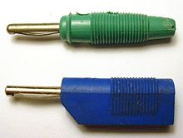IMAGE showing banana connector